Scenario: check windowhandles
Step: Launch "alertspage" WebPage - PASS
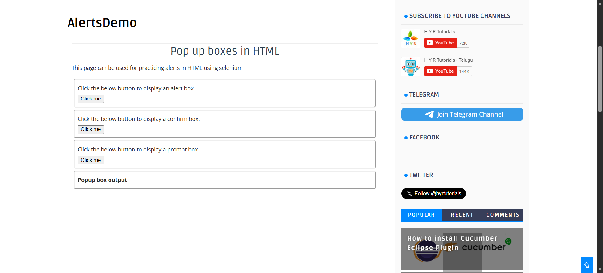
Step: User click the "click" element at "WHPage" page - PASS
Step: Then the user switches to alert and get text from alertbox - PASS
Step: Then the user switches to alert and enter"RAMYA" into alert box - PASS
Step: Then the user switches to alert and get text from alertbox - PASS
Step: Then the user switches to alert and click OK button - PASS
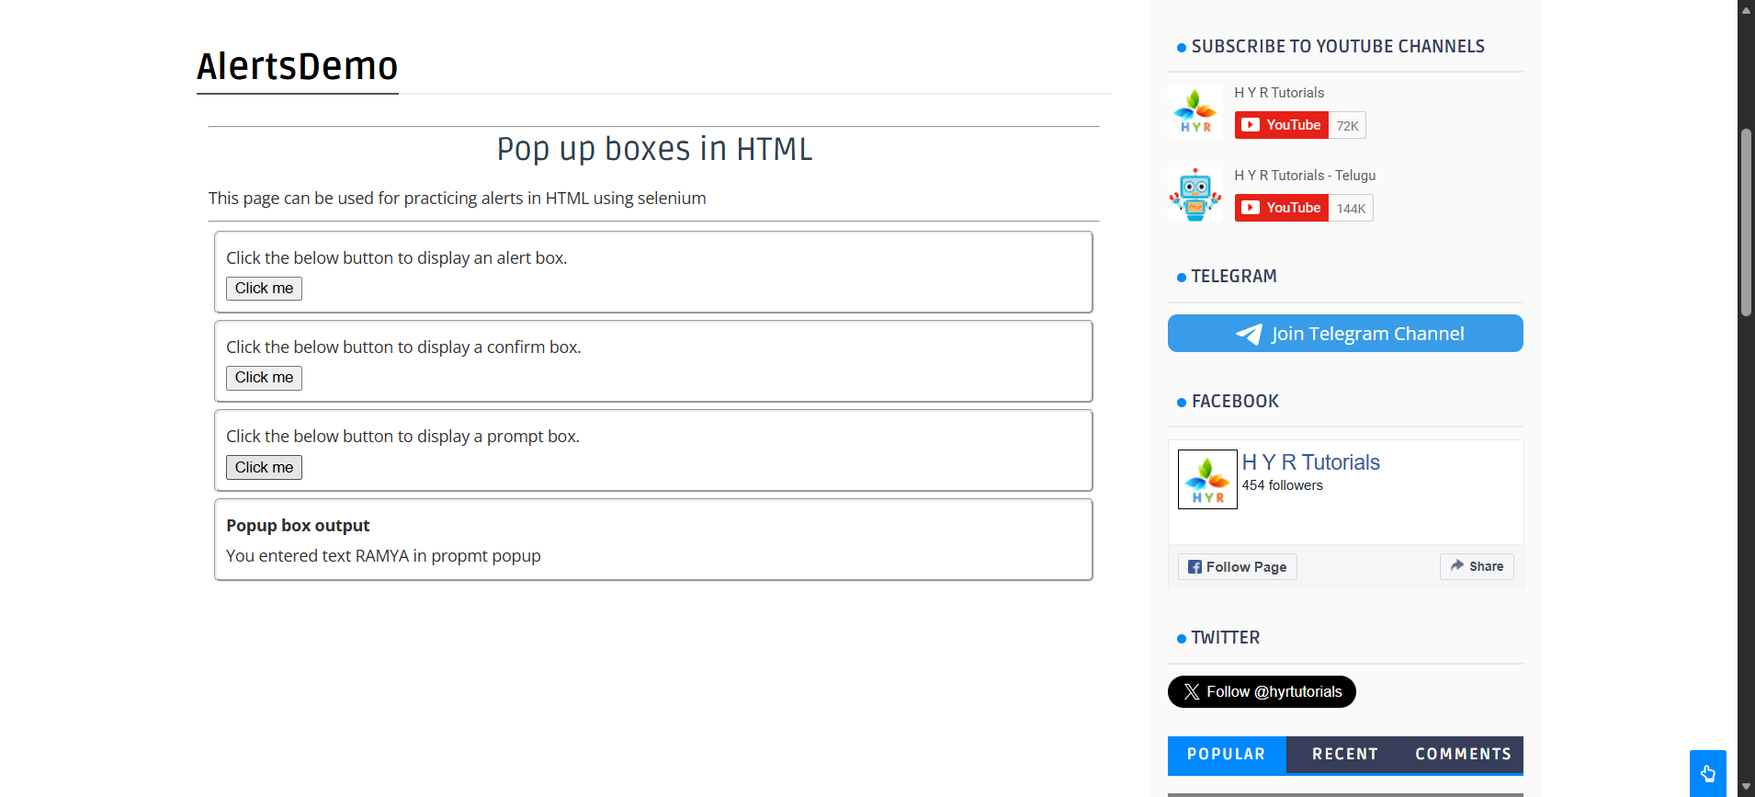
Step: And the user Get the text from"text" in "WHPage" page - PASS
Step: And the user waits for "3" seconds - PASS
Execution Summary:
Total Steps: 8
Passed: 8
Failed: 0

